**CURRICULUM VITAE**

**Personal Details**

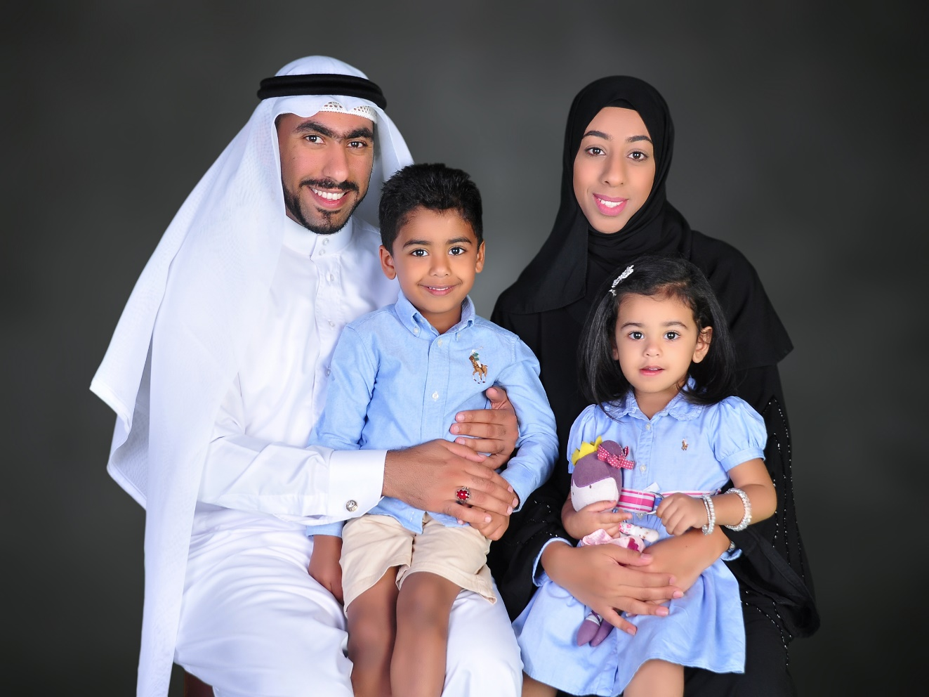

**Name:** Zahraa Jaffar Ali Ebrahim

**Date of Birth:** 21stFebruary1991

**Nationality:** Bahraini

**Gender:** Female

**Personal Number (CPR):**910202621

**Address:** building 1197, Road 5640, Block 756, bouri, Bahrain

**Contact Number**: (00973)33335707-39991494

**Email**: [Zahra-alghuraifi@hotmail.com](mailto:Zahra-alghuraifi@hotmail.com)

**Objective**

Wants to obtain a position that maximize my business skills, quality assurance and training experience

**Educational Qualifications**

2009-2014 University of Bahrain

B.Sc. in business management

2006-2009 Al-Ahd Al-Zaher Girls’ Secondary School

Secondary Certificate with GPA of 90.9%

Unified Stream- Science Specialization

**Work Experience**

2014

Northern area municipality – “Member of the human resources department”

Job position: Trainee

Key responsibilities:

* Organize and maintain personnel records
* Update internal databases (e.g. record sick or maternity leave)

2016-present "Temporary contract"

AL-AWQAF AL-JAAFARIA

Job position: Coordinator “customer service”

Key responsibilities:

* Daily Communicate with hundreds of individuals,
* Monitoring the team's performance, and assisting the team by performing the services to customers with them.
* Directs visitors by maintaining employee and department directories; giving instructions.
* Reply to contacts and answer their queries In addition to displaying the services of the institution
* Make a record of all the numbers and information about the callers and visitors.
* Take notes and suggestions from visitors
* Schedule appointments and interviews
* Maintains security and safety by following procedures; monitoring logbook; issuing visitor badges. In addition, solving customer problems

**Qualifications**

* **Computer:** Excellent user of Microsoft Office (Excel, Word & PowerPoint).
* **Presentation:** Able to produce reports and presentations to a professional standard.
* **Organisational Skills:** Effective at time management and prioritising tasks to meet deadlines.
* **Interpersonal Communication:** Positive group dynamics, leadership and communication skills.
* **Languages:** Arabic - written and spoken (Fluent).

English - written and spoken (Good).

**Interest**

* Business
* Art and science
* Travelling
* playing basketball
* reading narratives and cooking during free time.

**References**

References will be available on request.